**360° Virtual Tour - CEG Campus**

**Summer Internship Project**

**Centre for Immersive Technologies**

Report for 360° virtual tour application

By

Srihari S

UG 2021-2025, DME

CEG, Anna University

Rushil A. Krishnan,

UG 2021-2025, DCSE

CEG, Anna University

Industrial Mentor – Mr. Senthamizh,

XR Dev, The DreamX, Chennai

Guide – Dr. S. Chitrakala,

Professor - DCSE,

Director - CIT

CEG, Anna University

Guide – Ms. M. S. Karthika Devi,

Asst. Professor - DCSE,

Deputy Director - CIT,

CEG, Anna University

Table of Contents

**Project Description 3**

Project Overview 3

Purpose of the project 3

**Objectives 4**

**Methodology 4**

Current Situation 5

**Partitioning of work 5**

**Assigned Tasks 5**

**Flow of Work 6**

**Project Timeline 7**

**Phases 8**

Planning 8

Storyboard 8

Identifying locations to be included 9

Conduct site visit to plan storyboard and capture content 9

Frontend Development 10

Backend Development 11

General Working 11

Content collection 12

Integration and deployment 14

Backend and Frontend interaction 14

VR Integration 14

Deployment 14

**Challenges 15**

Frontend 15

Backend 15

**Scope for Improvement 16**

Frontend 16

Backend 16

**Deliverables 17**

# Project Description

## Project Overview

To provide an immersive tour of Anna University’s campus via mobile and PC via the web as well as elucidate the features of each and every place with an audio playback, topped off with relaxing music throughout the tour.

## Purpose of the project

College of Engineering Guindy is the oldest technical institute in Asia founded in 1794 and even to this day the buildings and surroundings in the campus provide a magical experience that transports you back to the past. But the opportunity to be present in this campus is not available to all. So this project is designed to provide a seamless portal to the user to experience the glory of this campus anywhere they might wish to do so with their own devices.

# 

# 

# Objectives

* To provide an immersive tour of CEG campus.
* To make the tour available in various platforms such as mobile, PC.
* To make the functionality seamless and lag free.
* To provide information to the user about each location they visit to make it feel like a guided tour across College of Engineering Guindy Campus, Anna University.

# Methodology

The methodology adopted during the creation of this project is the agile methodology.

The project was broken down into various phases from the start to make collaboration as well as assigning individual tasks easier.

The major phases in the project were Frontend development, Backend development and content collection. Each phase was further sub divided into categories and assigned to team members to make collaboration easier as well as to enable each person to proceed on their work without waiting for the other person to complete their task enabling the whole team to work smoothly and efficiently.

For continuous improvement in the package there were weekly meetings held with constant feedback loops with an industry expert to see what the end user requires and what will give them the best possible user experience. During said meetings the team members could clarify any queries that they might have and then further work on the improvements or new features required. Thus there is constant interaction between individuals over processes and tools.

# 

# Current Situation

Prior to the implementation of this project the CEG campus can only be visualised in a 2 dimensional way with no depth or immersion. There is no way to experience all locations in every possible direction. Even in existing virtual tours there is no way to understand the placement of landmarks and locations with respect to one another.

# Partitioning of work

The three main phases of this project are Frontend Development, Backend development and content collection. Each of the following phases will be explained further to understand why each of the following were developed to achieve the set objectives. Then following these three phases integration of the platform takes place and the project is made ready for deployment.

# Assigned Tasks

Planning Srihari S

Backend Development Srihari S.

Frontend Development Rushil A. Krishnan & Srihari S.

Content Collection Rushil A. Krishnan & Srihari S.

Integration Rushil A. Krishnan & Srihari S.

Deployment Srihari S.

# Flow of Work

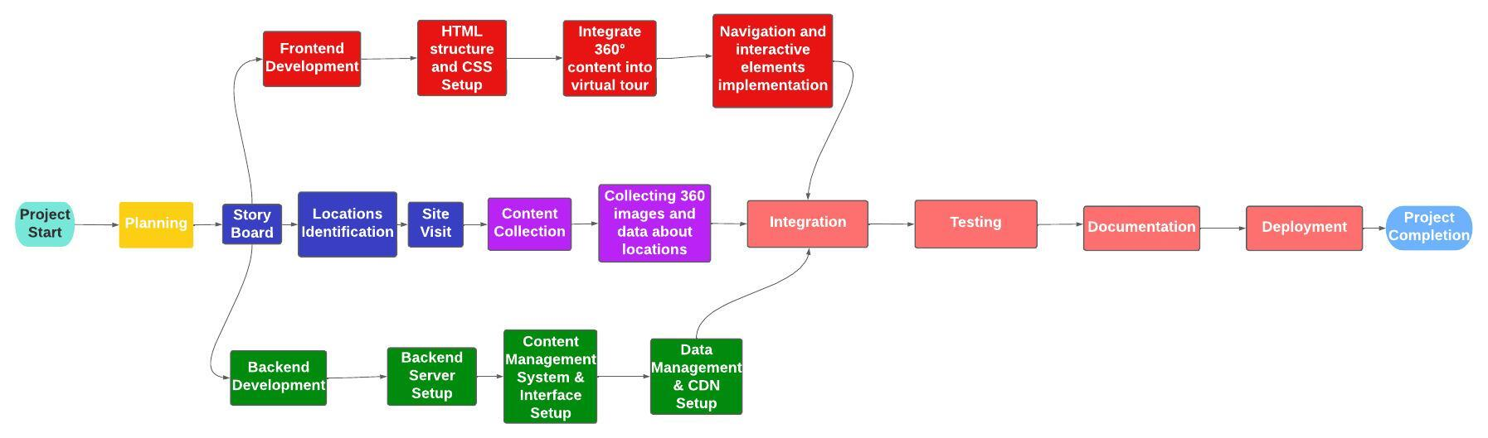

# Project Timeline

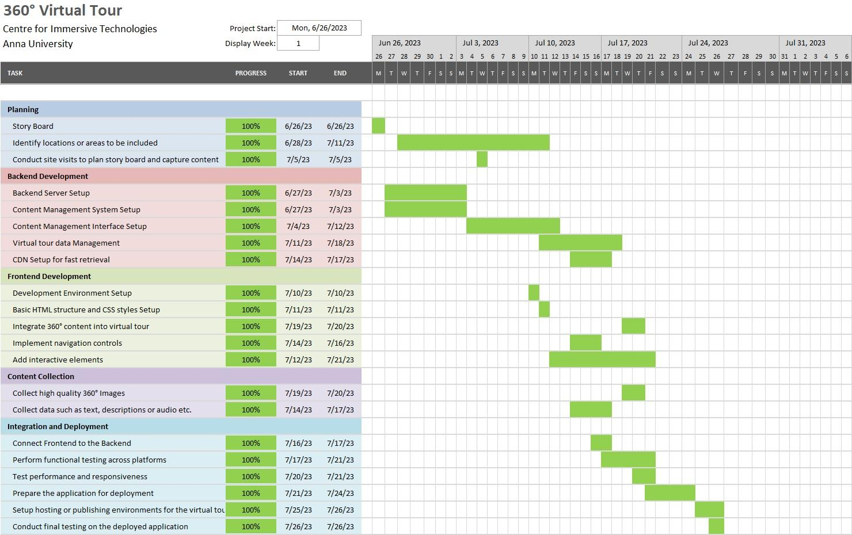

# Phases

## Planning

#### Storyboard

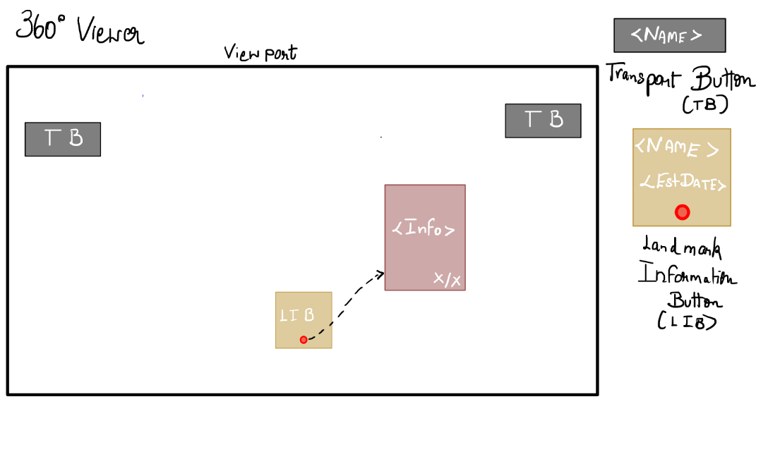

The above story board was created during the beginning of the project development to give a baseline on the type of platform that the user shall experience when using the webapp.

The transport buttons are the pathway through which users can choose which place next to visit

and interact with the button by clicking them.

The Landmark Information Button when clicked upon will open an information bulletin with appropriate information regarding the current location.

#### Identifying locations to be included

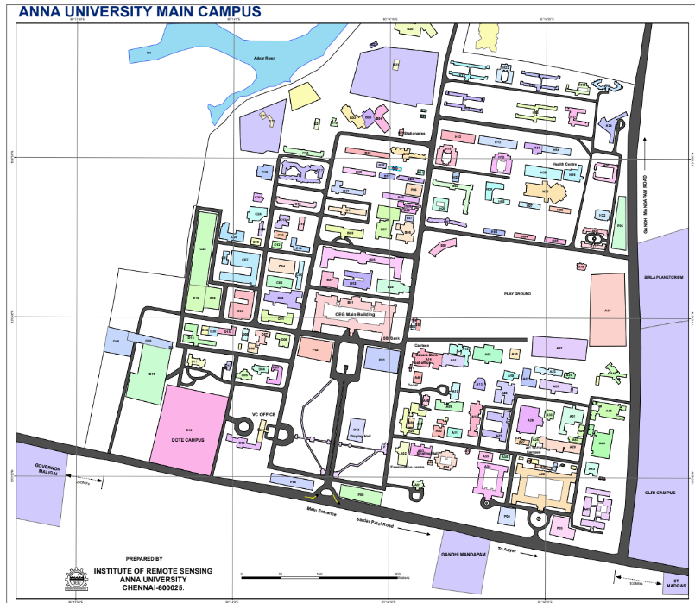

The following Anna University campus map was utilised to identify the locations to be included as places of interest in the planning stage. For preliminary purposes the information was recorded as a text file. Including all landmarks, preliminary walkthrough resulted in about 50+ landmarks.

#### Conduct site visit to plan storyboard and capture content

With reference to the map above the site of CEG campus was visited and a photo of each point of interest was taken to get a better picture regarding the directions that the transport buttons need to be placed to ensure proper connectivity between each location.

## Frontend Development

**Languages/Frameworks used:**

* A-Frame - <https://aframe.io/> - Used to render 360 images in the skybox, and place the description panels and arrows in the scene.
* HTML - Used as the skeleton of the website on top of which A-Frame and JS functionalities are used
* Javascript - Used in front end with A-Frame to add event functionalities to components, and used in back-end to request content from the database.
* Vite - <https://vitejs.dev/> - frontend tool that is used to create optimised build for webapp

**API/Assets used:**

* BGM - <https://pixabay.com/music/bossa-nova-bossa-nova-156936/>
* Text to Speech API - <https://cloud.google.com/text-to-speech>
* Display images (From Anna University official website) - <https://www.annauniv.edu/>

## 

## 

## 

## 

## 

## 

## 

## 

## Backend Development

**Languages/Frameworks used:**

* Express.js - <https://expressjs.com/> - back end web application framework used for building RESTful API with Node.js
* Mongodb Atlas - <https://www.mongodb.com/atlas> - cloud database used for storing and retrieving data to the frontend using the backend api
* Amazon S3 - <https://aws.amazon.com/s3/> - Object storage built to store high quality images, audio and other files. In this project we’re using it to store images and audio.
* Amazon IAM - <https://aws.amazon.com/iam/> - Identity & Access Management used for securely connecting to AWS S3 to manage access and prevent unwanted public access. So all files from the backend goes through an IAM user to S3 to get updated.
* Amazon Cloudfront - <https://aws.amazon.com/cloudfront/> - to ensure low latency of image transfer from S3 to the frontend.
* Python - (for initial data upload) Used to directly send CSV to the database without manual input.

**API used:**

* Created RESTful API to be used on backend with all CRUD operations

#### General Working

* The backend works in such a way that the database contains all information to be accessed using the frontend using the location name as the key.
* Using said information the images from S3 can be accessed via the cloudfront.
* errorHandlers and Loggers are created to find errors that have taken place as well as the general requests sent to the website.
* CORS is established by allowing only certain origins set in the backend to send requests that are responded to increasing the security of the site.
* Various packages such as: aws-sdk, cors, express, mongoose, multer, node-fetch, uuid are used to accomplish proper interconnectivity and functionality between platforms.

## Content collection

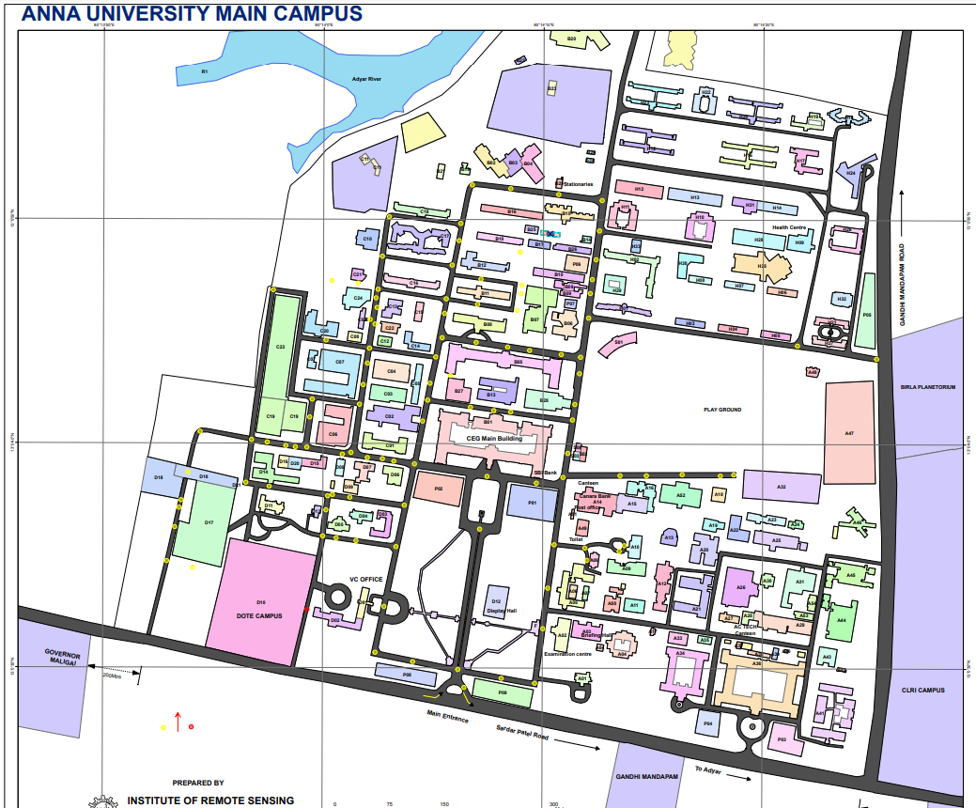

The points marked are the points where the data had to be collected and 360° images had to be taken. Then the neighbouring points were also noted with respect to one another to form a graph which shall be used to form the network that facilitates movement between each place.

Essentially acts as a node and the connections between neighbouring nodes acts as edges. The primary data of each node is the name of the place using which all additional data can be obtained.

The above map shows the whole Anna University Campus but the scope of this project is only with respect to the CEG Campus.

Google sheets with appropriate column data were used to record relevant data (text, descriptions, audio etc.) with respect to each place and it was planned in such a way that this sheet can be downloaded as a CSV file to be used with python to upload all information directly to the database.

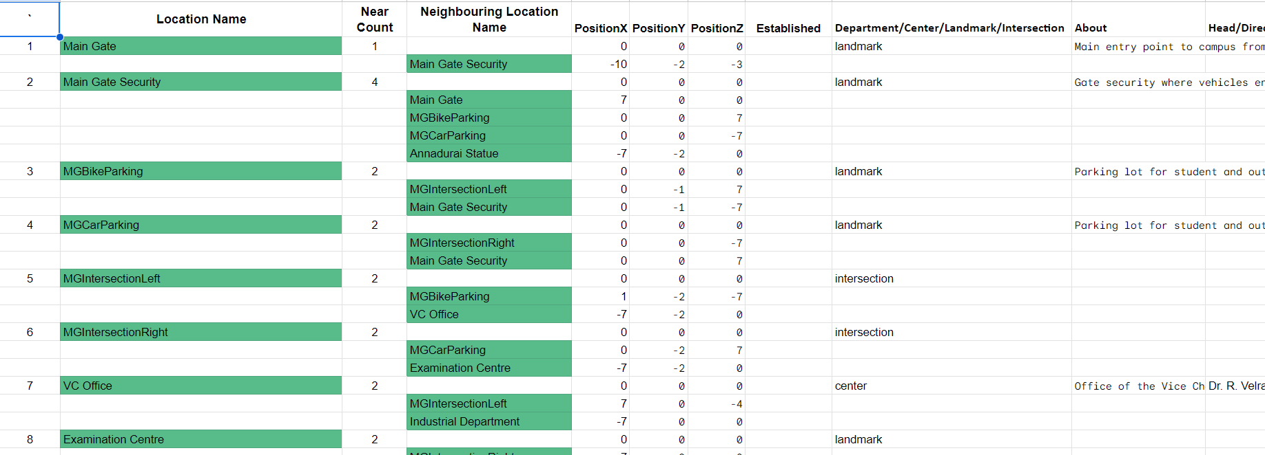

Snapshot of sheet

Insta360 ONE X was used to capture high quality 360° images. This device utilises 2 cameras, one in the front and one in the back, together they capture 2 domes of images which they then combine together to form 1 complete 360° image. The device was connected to the insta360 app via wifi and the app was used as the controller to take the images required.

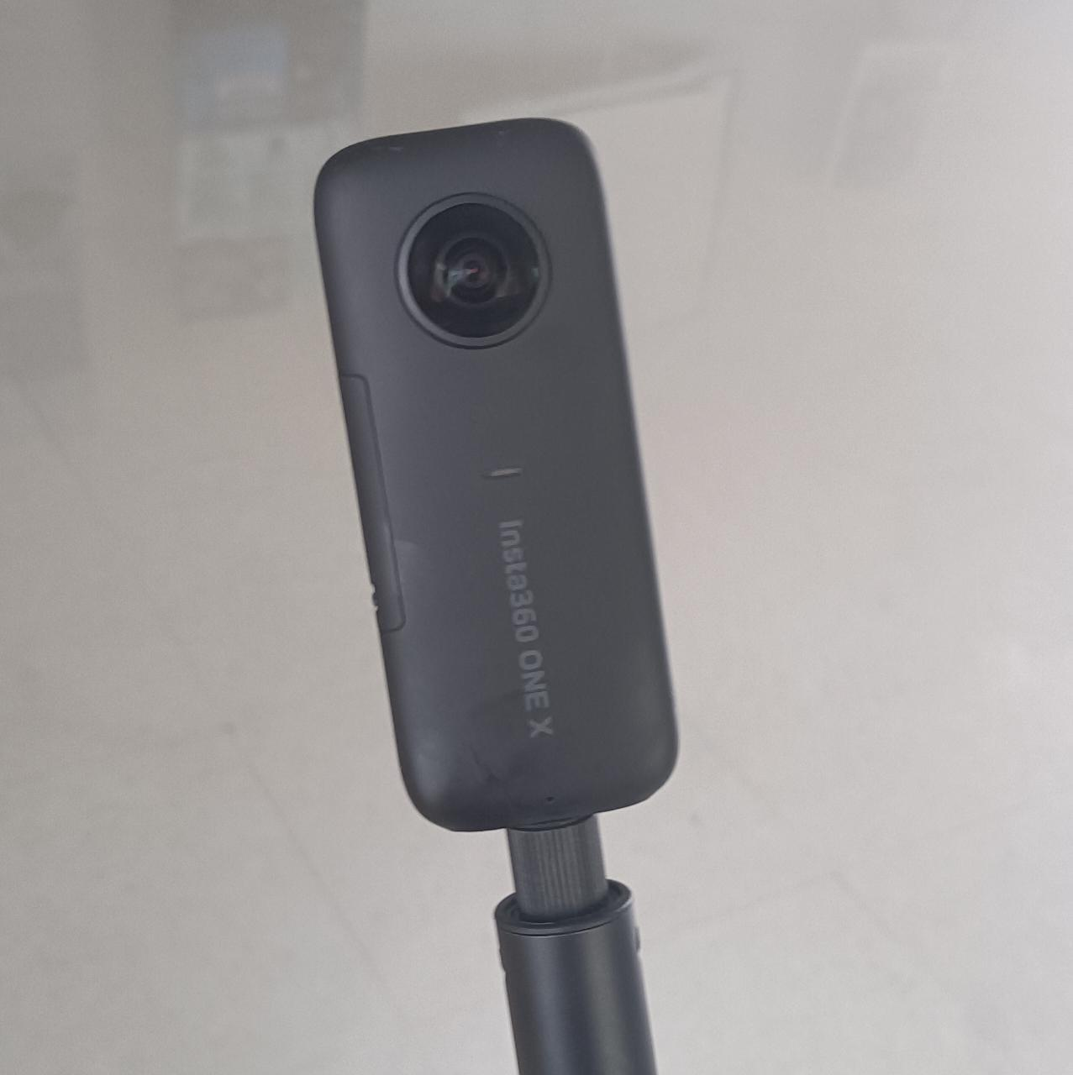

Insta360 ONE X

## Integration and deployment

### Backend and Frontend interaction

Frontend gets its required data by fetching information from the backend API as well as directly from the cloudfront for the images it requires. For this to work frontend has to be included as an allowed Origin in the backend.

### VR Integration

* The project supports WebVR and has capabilities to support VR headsets, though it has not been tested yet.
* This support is a feature of A-Frame that allows smooth integration of the website to VR devices and brings a WebVR experience on browsers without the use of VR devices as well.
* This can be tested by using the website on a mobile device as it supports gyro controls. By rotating the device, the cursor’s line of sight moves along the direction of rotation similar to the movement experienced in a VR headset.

### Deployment

Currently the site is deployed on render.com.

The frontend is deployed as a static website and the backend is deployed as a web service.

This platform allows easy updation and deployment of code as you can manually or automatically make your git pushes deployed onto the main website.

# 

# 

# Challenges

## Frontend

* Inability to add user interface controls like Zoom In, as it would distort the scene.
* Lack of sufficient resources for A-Frame that could have enhanced the experience.

## Backend

* CORS (Cross-Origin Resource Sharing) issue

Usually solved by adding CORS configuration directly to the S3 Bucket. But in this case this solution didn’t work because chrome and other web browsers since they use cache remove the headers that allow the CORS issue to be resolved. Disabling cache in said browsers would resolve this issue but that would impact performance of the website as the website utilises cache to load images faster. So after a cloudfront CDN service was added the response header policy was updated to permit the website to Allow Cross Origin requests to be able to resolve this issue.

* Initially the S3 bucket was directly requested to be sourcing images to the site. But the latency of that was too high so switching over to Cloudfront allows users to cache the image once they load and hence experience quick load times.
* Aframe has some issues with respect to changing attributes of custom components. So if the component didn’t have the particular attribute already set we could use the .setAttribute to update the attribute value but if it already possessed value for the attribute the .setAttribute doesn’t work and there are some issues in the init and update functions of the custom component. To overcome this issue we instead used the innerHTML tag in javascript to re-render the transport arrows in the desired spot after getting required data from the database.

# Scope for Improvement

## Frontend

* Visuals and responsiveness of UI could be improved based on user feedback.
* Lag between scene transitions could have been masked with fade animations.
* Description panel could have been placed on the front face of each landmark.
* A separate menu for Settings could be made which controls gyro speed, sound volume, and even change the background music played.
* There is a provision to make the website start at a different location instead of starting at the main gate but that is currently not implemented as the main focus of this project is to cover the whole campus hence the most suitable starting point is the main gate of the campus. But the ability to start at a different location provides more opportunity to use the site on different departments’/centres’ websites to showcase their location in an immersive way.
  + Suggested way: Using ?<location> added to the url and using that <location> name to change the initial pointing location of the arrow in the front end. These changes can be done in the script.js file in the frontend code.
* Currently the website functions on pc browsers and most android mobiles. IOS devices alone require additional permissions. This has to be added to enable ios devices to access this site using its gyroscope.

## Backend

* Addition of image for description box now has to be done manually by adding _1 to end of location name in patchImage form in backend but this as well as the above audio addition can maybe be put into the original Upload Location form but the middleware used to get file maybe has to be changed or has to be checked whether that upload middleware can support more than 1 instance of files at a time.
* Since the locations are structured as nodes of a graph, related algorithms and methods could be exploited to find a path between locations efficiently allowing users the opportunity to know the exact route to their desired location as well as to get their bearings related to the path.

# Deliverables

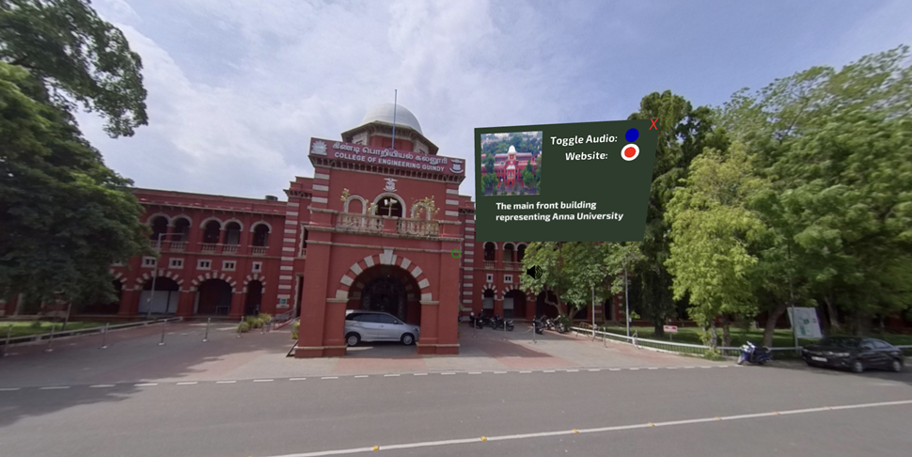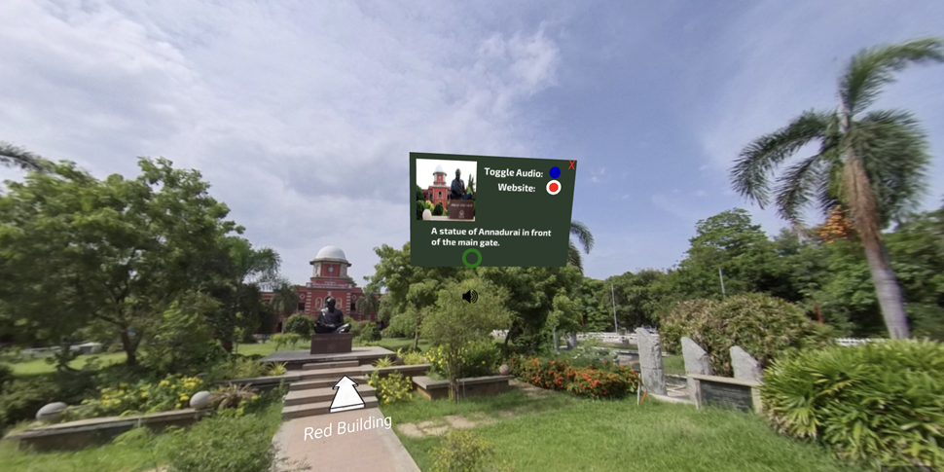

Including above locations there are over 112 locations of the CEG campus which are currently available to be experienced in this virtual tour.